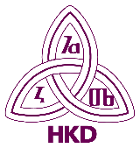
Croatian Library Association’s Reading Committee
“It is beneficial for every society to systematically and strategically deal with issues of reading culture because reading is a basic competency for life.”
Lj. Sabljak
ABOUT US

READING COMMITTEE was founded on December 19, 2003 as the Work Group for Reading, on the proposal of Ljiljana Sabljak, and in accordance with the Croatian Library Association’s Statute and Rules of Operation. It became the Committee at the Croatian Library Association’s Assembly in Pula in 2008.
It operates within the Division for Public Libraries. It can consist of up to 11 regular members who become candidates through regional associations. Currently, it consists of 11 regular members, and 5 associate members who work together and proactively.
REGULAR MEMBERS:
- Aleksandra Cvitković
- Ivanka Ferenčić Martinčić
- Ivana Freškura
- Arijana Herceg Mićanović, President
- Romana Jadrijević, Deputy President
- Margareta Matijević Kunst
- Tatjana Petrec
- Maja Pranić
- Draženka Robotić
- Ivana Sabljak
- Pamela Sever
ASSOCIATE MEMBERS:
- mr. sc. Lorenka Bučević-Sanvincenti
- Franciska Jurišić Bačić
- dr. sc. Alica Kolarić
- Grozdana Ribičić
- dr. sc. Ljiljana Sabljak
PRESIDENTS:
2003. – 2008. Ljiljana Sabljak
2008. – 2012. Davorka Semenić-Premec
2012. – 2016. Lorenka Bučević-Sanvincenti
2016. – 2020. Grozdana Ribičić
2020. – Arijana Herceg Mićanović
MISSION of the Reading Committee is to promote, study, and improve reading and literacy, within the framework of the library profession.
While aiming to complete its’ mission, Reading Committee strives to maintain a balance between various kinds of libraries when developing strategies for reading competencies and literacy, in line with the National Strategy to Promote Reading. It designs projects and models for the development, improvement, and advancement of various aspects of literacy, in cooperation and partnership with the IFLA Committee for Reading, Croatian Library Association’s Committees, and other institutions and associations, in order to raise the rate of literacy and improve reading culture.
OBJECTIVES - The Reading Committee deals with current and development issues of literacy and reading in libraries. It systematically monitors, promotes and teaches reading techniques. It works on upgrading levels of literacy designing special programmes for all social and age groups of library users. It deals with development of reading literacy and promotes active and critical reading.
It cooperates with other Committees and divisions of the Croatian Library Association as well as other related associations and institutions.
The Committee publishes overviews of experiences, professional and scientific papers in professional journals in Croatia and abroad.

READING COMMITTEE HISTORY
READING COMMITTEE was founded on December 19, 2003 as the Work Group for Reading, on the proposal of Ljiljana Sabljak, and in accordance with the Croatian Library Association’s Statute and Rules of Operation. It became the Committee at the Croatian Library Association’s Assembly in Pula in 2008.
It operates within the Division for Public Libraries. It can consist of up to 11 regular members who become candidates through regional associations. Currently, it consists of 11 regular members, and 5 associate members who work together and proactively.
Reading Committee deals with current and development issues on literacy and reading in libraries and in society in general. It systematically monitors, promotes ant teaches reading techniques. It works on upgrading levels of literacy with special programmes for all social and age groups of library users. The Committee publishes overviews of experiences, professional and scientific papers in professional journals in Croatia and abroad.
IFLA’s Section on Literacy and Reading has published “Guidelines for Library-Based Literacy Programs” during its’ 2003 Berlin conference. In 2004, Reading Committee translated them into Croatian, and they were published by the Croatian Library Association in 2005 as the Guidelines for easy-to-read materials.
On the 14th European Conference on Reading in Zagreb in 2005, poster presentation disclosed the results of the survey about reading preferences in public libraries in Croatia. That same year on IFLA conference in Oslo poster presentation presented reading competencies in Public libraries in Croatia in the context of Croatia’s preparations for entering the EU. Reading Committee is the co-organizer of thematic round tables initiated by the Committee for Library Services for People with Disabilities and Special Needs.
Committee has been actively involved in the organisation of professional meetings with Croatian Reading Association celebrating the International Literacy Day. Committee co-operates with the Croatian Library Association’s Committee for Library Services for Children and Young People, Committee for Public Libraries and Committee for School Libraries.
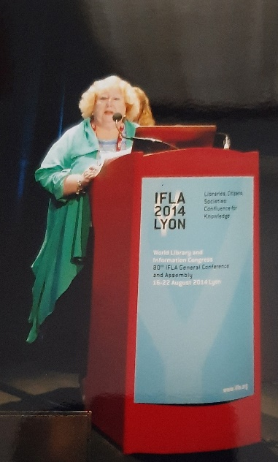
In 2012, Lesley Farmer and Ivanka Stričević presented the translation of IFLA’s guidelines on the round table “Gifted children in the library and the library for gifted children”. Guidelines Using Research to Promote Literacy and Reading in Libraries, contain an addition with research on literacy and reading in Croatian libraries.
Since 2016, Reading Committee is one of the co-organizers of the National Campaign for Persons with Reading Difficulties and Dyslexia „I want to read too!”, together with the Committee for Library Services for People with Disabilities and Special Needs. One of the main aims of the campaign was reached when the copyright law was added sections 86.a and 86.b. These sections determine the usage of author’s works for people who are blind, visually impaired or have other difficulties using standard print, including persons “with perceptive difficulties or reading difficulties, so they can’t read print the same way other people can”. That is an indicator of the power of librarian activism.
In the same way, the involvement of Croatian Library Association and its’ Committees was very important in giving suggestion and objections on the Proposal of the Law on Library Activities and Libraries in 2018, because some of those important suggestions were adopted.

COMMITTEE TODAY
In time of uncertainty, existential anguish, institutional distrust, media manipulations and communication noise, which result in weakening of intellectual and linguistic power of an individual but also in the erosion of mental and emotional health – libraries hold an important place. We believe that the librarian community is strong enough to withhold that place in the future.
Libraries and librarians greatly contribute to the development of the reading culture through longstanding systematic and continuous engagement, often unvalued and publicly “invisible”. We ask for that effort to be valued and recognized, and to invest more financial and intellectual resources that would even more strengthen and empower the librarian community for their activities.

FACEBOOK PAGE READING – ENCOURAGEMENT AND RESEARCH
Reading committee has formed a FB page on June 24, 2018 with the goal of collecting projects, programmes, and research in connection to promotion of reading and literacy.
Purpose of the page is to increase visibility of similar projects, programmes and research, and make them available for further use.
PILOT PROJECT READING – ENCOURAGING AND RESEARCH
In 2019, Reading Committee launched a pilot project READING – ENCOURAGING AND RESEARCH: A Croatian database.
The purpose of this project was to collect and unite in one place reading encouragement programmes and research on reading in The Republic of Croatia.
In 2020, the Reading Committee worked on the second phase of the pilot project READING – ENCOURAGING AND RESEARCH: A Croatian database. The site and its functionalities were tested. It was noticed that the project is extremely demanding in several segments and detected and analyzed what is needed to optimize such a website. Through its engagement, the Reading Committee has gained valuable insights that can contribute as guidance for the development of a similar, professionalized and institutionalized site in the future.
In 2021, there was a shift in focus in the work of the Reading Committee, and this change has resulted in new acitivities.
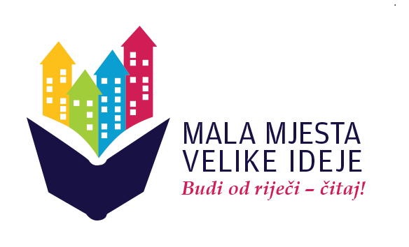
DEVELOPMENT PROJECT BOOKS AND READING PROMOTION AS A DEVELOPMENT POTENTIAL FOR SMALLER CITIES
Reading Committee whose mission is to promote, research and improve reading and literacy within the framework of the library profession, started this project in 2022, based on the National Strategy to Promote Reading and with the support of Ministry of Culture and Media of the Republic of Croatia.
Aim of the project is to promote cultural and social development of small towns, make culture and heritage more visible, inspire librarians to do creative and innovative activities and thus contribute to cultural and economic development of the local community.

Roundtable in Prelog
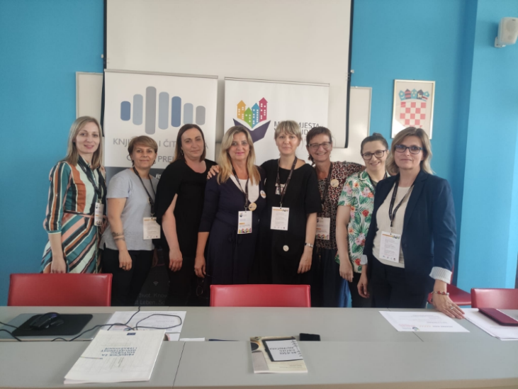
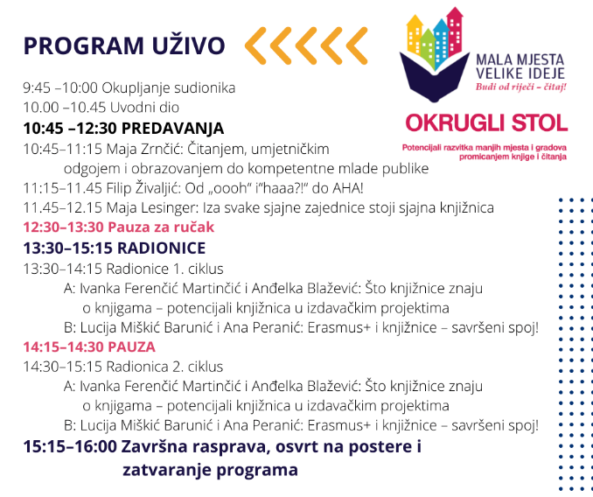
In an effort to highlight real and numerous potential of libraries in small towns, Reading Committee together with Prelog Municipal Library held first roundtable discussion on June 10, 2022. Prelog Municipal Library was chosen because of its’ proactive and creative new ideas.
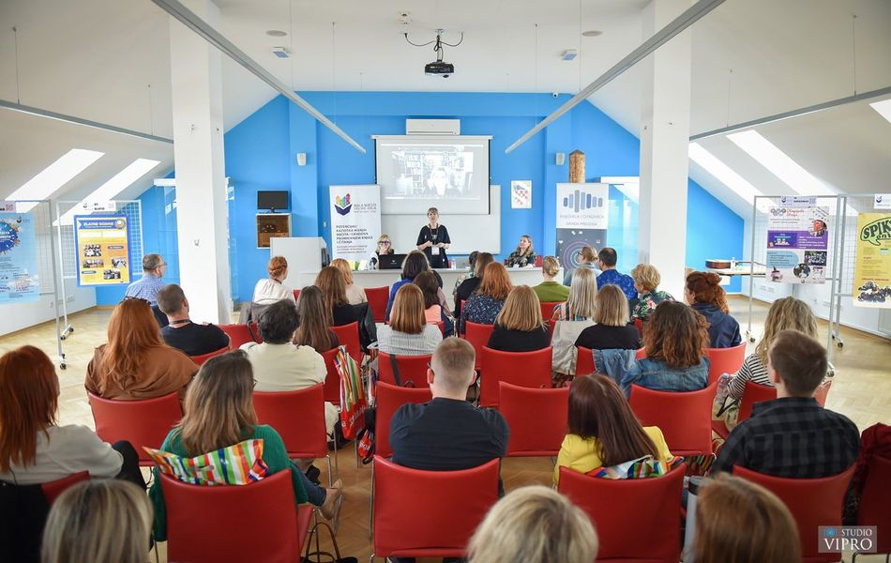
Roundtable in Daruvar
In cooperation with the Section for Public Libraries of Croatian Library Association and Daruvar Public Library, Committee organised second roundtable on May 19, 2023 on the Books and Reading Promotion as a Development Potential for Smaller Cities aiming to empower development potentials.
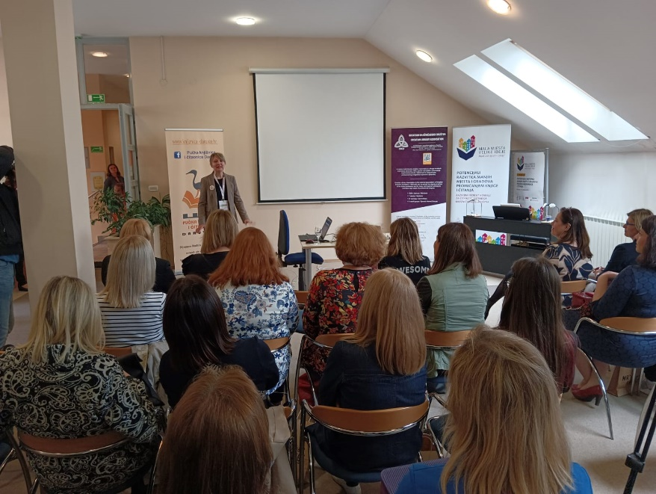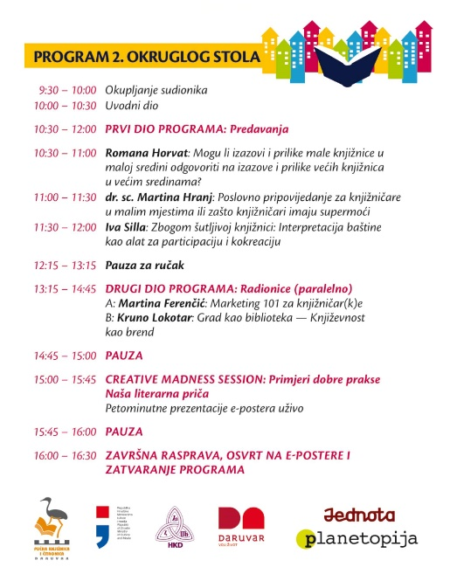
PARTICIPATION IN PROFESSIONAL MEETINGS
28TH (online) ZLA forum “Libraries, cultural tourism & reading culture” (May, 2022)
Presentation Big enough for not to be small
Ivana Freškura, Margareta Matijević Kunst

47th ELECTORAL ASSEMBLY of CROATIAN LIBRARY ASSOCIATION (Zadar, October 2022)
Poster presentation Geography of Reading: Books and Reading Promotion as a Development Potential for Smaller Cities
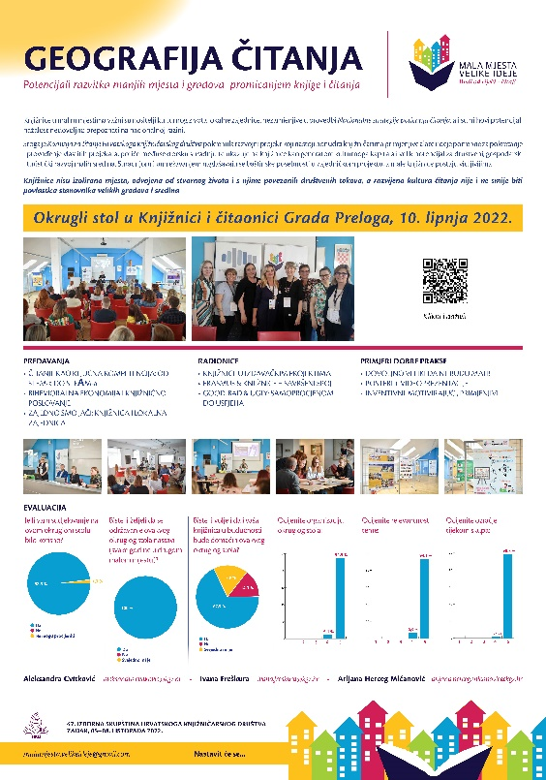
Aleksandra Cvitković, Ivana Freškura, Arijana Herceg Mićanović

2nd Roundtable Books and Reading Promotion as a Development Potential for Smaller Cities (Daruvar Public Library, May 2023).
Presentation “Interpretation of heritage as means for empowering libraries in the community”
Ivanka Ferenčić Martinčić

16th Roundtable on mobile libraries in Republic of Croatia and 10th festival of Croatian Bookmobiles
Mobile library in service of reading culture promotion (Split, May 2023)
Presentation “Small Towns– Big Ideas”
Ivanka Ferenčić, Romana Jandrijević, Maja Pranić
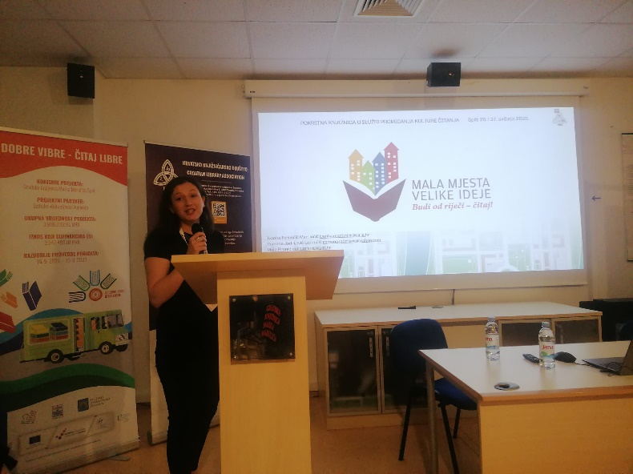

14th Croatian Conference on Public Libraries (Dubrovnik, October 2023)
Promotional movie Small towns – Big Ideas
Ivana Freškura, Arijana Herceg Mićanović, Ivana Končić, Maja Pranić

PUBLISHED PAPERS
Sabljak, Ljiljana: Book and How to Read it : manual for guided reading (bibliotherapy). Zagreb : Medicinska naklada, 2022, (Book and how to read it)

Pranić, Maja ; Herceg Mićanović Arijana Small places, great ideas: Be authentic — read! Novi uvez : Glasilo Zagrebačkoga knjižničarskog društva, Vol. XX No. 37, 2022.
Matijević Kunst, Margareta: Presentation of the Roundtable “Books and Reading Promotion as a Development Potential for Smaller Cities”. e-Bilten Hrvatskog čitateljskog društva, July, 2022.
Cvitković, Aleksandra ; Herceg Mićanović, Arijana ; Freškura, Ivana: Books and Reading Promotion as a Development Potential for Smaller Cities. Vjesnik bibliotekara Hrvatske, 66(1), May, 2023.

ACTIONS AND MANIFESTATIONS
Founding of a football reading club Drniš on the occasion of International Day of Literacy on September 8, 2023.
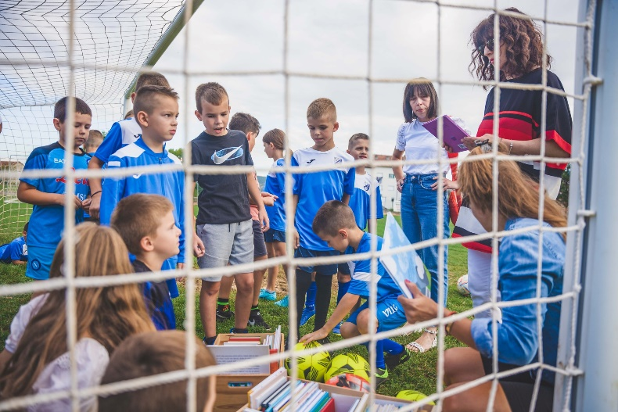
Promotional movie Small towns – Big Ideas
Ivana Freškura, Arijana Herceg Mićanović, Ivana Končić, Maja Pranić
Reading is a fundamental human right that has to be available to everyone, without discrimination. Promotional movie Small towns – Big Ideas was designed and made by librarians, in order to promote reading. First public premiere was on 14th Croatian Conference on Public Libraries in Dubrovnik, on October 13, 2023. It was made as part of the development project of the Croatian Reading Associations’ Reading Committee and it points out that libraries are not isolated places, separated from the real life and its’ social routines. Developed reading culture should not be the privilege of big towns and cities. Film was made with great enthusiasm, dedication and joy, and with zero budget!
The video raises awareness of the fact that reading is a fundamental human right that has to be available for everyone. In achieving and promoting the right to read libraries have a very important role. High level of literacy is a necessary prerequisite for any progress — economic, social, cultural and personal. A developed reading culture is not and should not be the privilege of inhabitants of large cities and environments.

Written by: Arijana Herceg Mićanović
Tatjana Petrec
Grozdana Ribičić
Ivana Sabljak
English translation: Margareta Matijević Kunst
Proofreading: Ivana Freškura

